Zdenko Zahorec

sbs22090@student.cct.ie

MSc in Data Analytics (SB+) - Feb 2022 - YR1

Lecturers:

Marina Iantorno

David McQuaid

Dr. Muhammad Iqbal

Continous Assignement 2

Irish Organic food case study

Contents

Abstract 3

Introduction 4

Conclusion 17

References 18

Appendices 21

Figure 1 Cordons 4

# Abstract

Irish Agriculture…

# Introduction

According to …

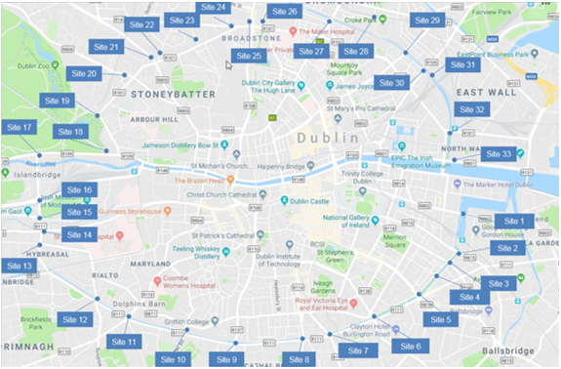

Figure 1 Cordons

Figure 1 (Dublin Cordon Points)

# Analysis

Organic food

# Conclusion

By using this dataset, we can build machine learning models to…

# References

1. Adèr, H.J. (2008). Advising on Research Methods: A Consultant’s Companion. [online] Google Books. Johannes van Kessel Publishing. Available at: https://books.google.ie/books?hl=en&lr=&id=LCnOj4ZFyjkC&oi=fnd&pg=PA333&dq=data+analysis+process+steps&ots=L2tblTW3jw&sig=fF-7Ya76YUUG4idfBW9yEbLKkLA&redir_esc=y#v=onepage&q=data%20analysis%20process%20steps&f=false [Accessed 2 Apr. 2022].

# Appendices

Appendix 1. Comparison of models performance with train/test split 0.1/0.9, 0.25/0.75, 0.3/0.7 Jupyter notebook line (In [79])